**Why do we need to use ServiceNow?**

Ticketing systems are how we prioritize and archive incidents that happen daily. ServiceNow is just one of the many ticketing systems we can use to accomplish these tasks.

**What you will need**

* Access to company network
* Access to company VPN
* Company badge
* ServiceNow account

**Process Steps**

1. Find the link to the company’s ServiceNow home screen address located in Microsoft SharePoint
2. If you do not have a ServiceNow account yet, report to your manager immediately
3. Once you are on the ServiceNow homepage, click on Incidents > Create New located on the left side of the screen

1. In the “Caller” field, enter your name or the name of the ticket requester



1. In the “Contact Type” field, enter the method of contact used for the incident request

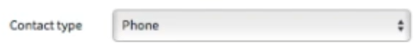

1. Enter the category of the incident in the “Category” field



1. Enter the subcategory of the incident in the “Subcategory” field



1. Enter the correct business service in the “Business Service” drop-down menu



1. Enter the Configuration Item in the “Configuration Item” box (this will usually be something like a database name, server name, website name, etc.

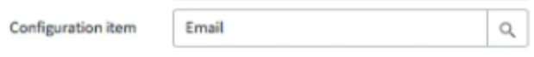

1. You can leave the “Impact” and “Urgency” boxes the way they are, unless the caller needs the issue taken care of right away. If this is the case, set both boxes to “Critical”.

1. The “Assignment Group” is the group that will solve the issue. Either enter in the group you belong to, or the group that handles the specific issue. Discuss who is responsible with your team.



1. If you are the agent who is responsible for resolving the issue, enter your name in the “Assigned to” field. If you are NOT the responsible agent, you can leave the box blank.



1. Enter the email subject into the “Short Description” box. If there is no automated email associated with the issue, you will have to create your own description of the issue.

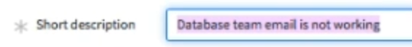

1. Enter the email body into the “Description” box. If there is no automated email or caller notes associated with the issue, you will have to create your own description of the issue.



1. Attach any screenshots related to the issue by clicking on the paperclip icon near the top of the page.

1. Click submit

1. Enter in any changes into the “Work Notes” section, such as escalations, conversations, status updates, etc.

1. Click on the “Resolution Notes” tab near the middle of the page, next to the “Notes” tab

1. Enter “Resolved” as the “Closure Code”

1. Enter how the issue was resolved in the “Closure Notes” section. For example, you can say “Space was deleted on the G: drive, and the full backup job ran successfully.”

1. Attach any screenshots relevant to the closure of the ticket by clicking the same paperclip icon as before

1. Click resolve

